# Data Analysis and Model Performance Report

Accuracy of the model: 0.70

## Confusion Matrix:

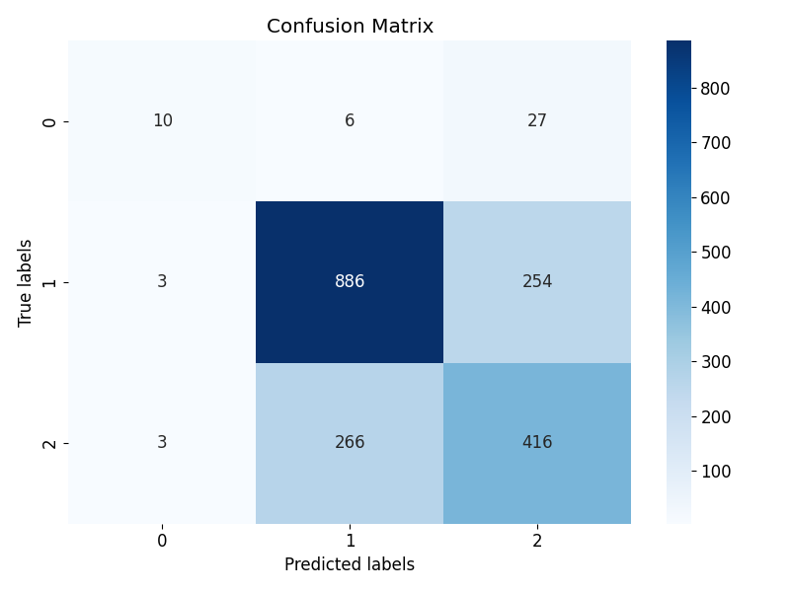

## Feature Importances:

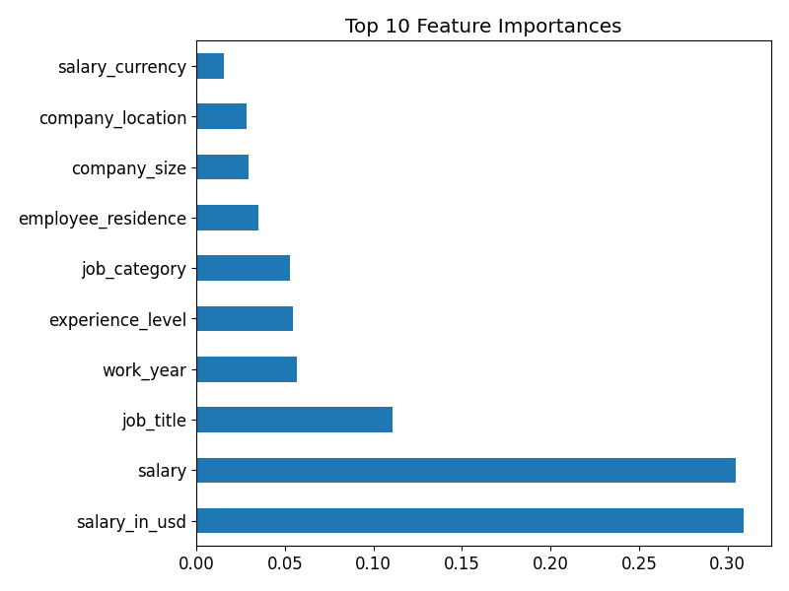

# HR Manager Recommendations

Based on the model's findings, we recommend focusing on recruitment and development in key areas identified as critical by the feature importance analysis...